The mclib Job Server Plugin module
Developed by Kyle Oedewaldt and Mike Zimmerman

Features 1
Queued Jobs Tab 2
Complete Jobs Tab 2
Job Viewer – Queued Job Tab 3
Job Viewer – Queued Job Tab 3
GUI actions 4
The Job Group Toggle 4
Status Toggle 4
Text Searches 4
Limiting Toggles 5
Count toggle 5
Changes to the Options Menu 6
Implementation within an Application 7
Configuration of GUI items 7
Setup of Job Groups 8
Appendix: Implementing the Job Server on the Administration Application 9
Appendix: Subclassing MClib job server plugin 10
Activation XML 10
Magik (/source) 10
Messages (/resources/en_us/messages) 10
Subclass MCLib Job server’s XML (/resources/base/data) 11
Example 11

Features
- Allows users to only display the job types they are interested in via implementer-defined job groups
- Allows users to display only those jobs of a certain status
- Allows users to perform text searches on several fields
- Allows users to specifically not display certain job types via implementer-defined toggles
- Allows users to only view jobs in a specific date window via new items on the Option menu
- Allows admin users to edit the selected job
- Allows admin users to export only the selected jobs or to export all the displayed jobs to the Explorer
- Provides additional information on the Job Information popup (job arguments)
- Bolds the currently running jobs and prevents their deletion without suspending them first
- Added the Windows Start field to the Queued Jobs Tab (critical info for repeating jobs)
- Optionally allows the calculation of result size for constructed queries

Most of these changes were implemented to make finding / displaying / examining jobs simpler. The system this was developed on currently has (as per the screenshots below) over 38K job records that get listed under the Completed tab. As the number of jobs got larger, the refresh time for the full list got worse.

Additionally, users had noted that the filters they defined in the tool (tree item) would not persist past a refresh (rollforward), making the initial gui refresh after a job queue rollforward quite long-running (as many as 3 minutes).

A modified version of the Viewer subclass is also provided.

Queued Jobs Tab

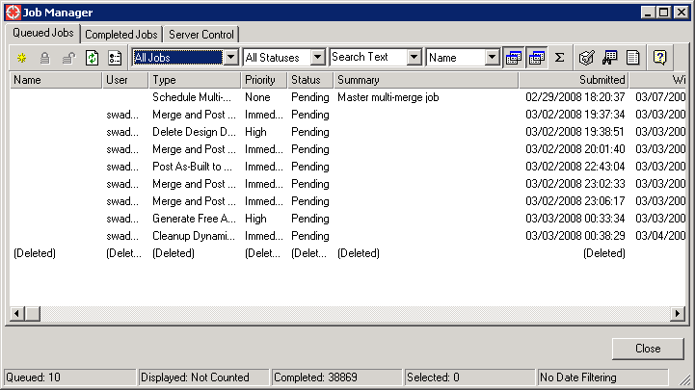

Complete Jobs Tab
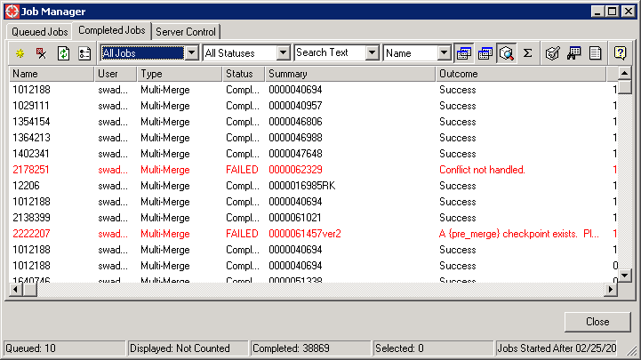

Job Viewer – Queued Job Tab
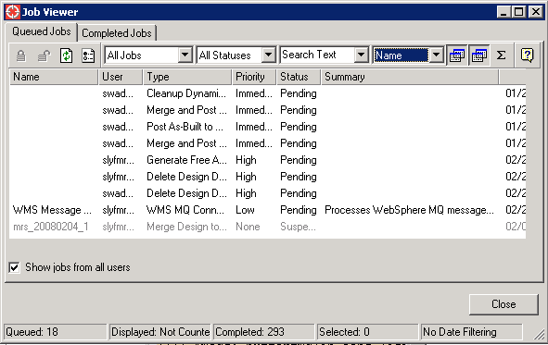

Job Viewer – Queued Job Tab
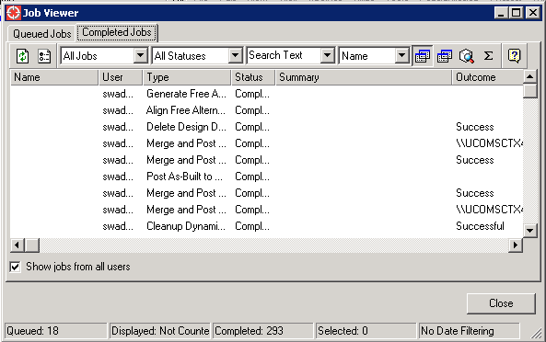

GUI actions

The Job Group Toggle

Without Customized Messages: With Customized Messages:

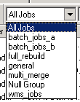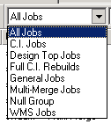

Job groups (defined by the implementer) allow for only certain types of jobs to be seen in the list at a given time. Changing the chosen job group will refresh the list. Note that the All Jobs and Null Group messages are provided in the module – the others listed above are just part of the example.

Status Toggle

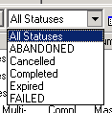

This toggle uses the Visible Status list already used on the respective core job server tabs (configured in config_process.xml and config_scheduled.xml) to allow the user to only display jobs with a specific status. Changing the chosen status will refresh the list.

Text Searches

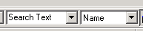

This text search item is the same type of search typically provided on the main application window, and allows the user to perform text searches on the relevant physical text fields already displayed in the core job server tabs (e.g.Name, User, Summary, Outcome, Server, Priority and ‘Repeats?’). Pressing Enter when you are done typing in the Search Text field will refresh the list.

Notes: to search on the ‘Repeats?’ field, use True and False instead of Yes and No; to stop searching by the text fields, simple clear the ‘Search Text’ item

Limiting Toggles

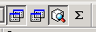

As with the above lists, toggling these items will refresh the list.

The first two toggles are defined and placed by the implementer in the XML and are generated by the system in a generic fashion. Whether or not a job of a given type is included in the displayed list is tied to the state of these toggles. In this example, they are controlling the display of the multi-merge and wms jobs noted above in the Job Group toggle example.

The third toggle controls whether or not only those jobs started after a given date and / or before a separate given date (specified on the Options menu detailed below) are included in the displayed list. The specified dates are displayed on the tabs to which they apply, as seen below – these texts are replaced with ‘No Date Filtering’ when this function is not enabled / not available. By default, the Mclib job server only applies date filtering to the Processed tab.

Ignore Before Set: Both Values Set: Ignore After Set:

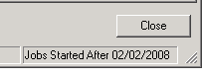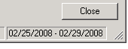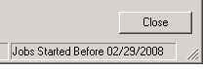

Count toggle

The count toggle controls whether or not the menu determines how many jobs are currently being displayed on that tab. This value takes a relatively long time to determine and significantly slows down refresh times, so it is off by default. It is recommended that a user simply turn it on so that it initially figures out the total and then turns it back off again.

Edits and Explorer Exports



(Given sufficient system permissions) the standard Edit button allows the user to edit the selected job.

There are two Explorer Export buttons – Export Selected or Export All – both cause the relevant jobs to be displayed in the Explorer where they can be further examined.

Note: The edit and export functions are not available on the viewer GUI by default.

Changes to the Options Menu

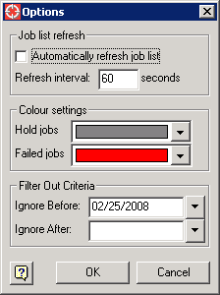

The Filter Out Criteria at the bottom of the menu allows the user to filter out all job records started before a specified date and / or after a specified date.

Implementation within an Application

As provided, this module requires the core job_server_plugin module and the mclib_package module to be loaded.

In the config.xml for an application that wants to use this plugin, change the following line from

<plugin name="job_server_activation_plugin" class_name="job_server_activation_plugin"/>

to

<plugin name="job_server_activation_plugin" class_name="mclib:mclib_job_server_activation_plugin"/>

Place the module in the system’s code tree appropriately, add it to any relevant build lists and rebuild the closed / open images.

At this point, the applications so changed will now bring up the modified version of the Job Manager. No further changes are necessary for the module to function correctly.

Configuration of GUI items

Limiting toggles

As provided, there are no Limiting toggles on any of the tabs. To add the job-type toggles, add the following section to the relevant config.xml files:

<filter_out_types>
<job_type type="job type to be affected" default="true or false"/>
</filter_out_types>

and add the following to the relevant gui.xml files:

<action name="show_ job type to be affected "/>

where the italics will be appropriately replaced by the job type in question. For example:

<filter_out_types>
<job_type type="multi_merge_scheme" default="true"/>
</filter_out_types>

<action name="show_multi_merge_scheme"/>

The above entries add a toggle to the toolbar that determines whether or not to show multi_merge_scheme jobs and is selected by default (those job types are shown when the menu opens, by default).

Date Limiting toggle
To add the date limiting toggle, add the following line to the relevant config.xml files:

<filter_by_start_date value="true or false"/>

and the following line to the relevant gui.xml files:

<action name="filter_by_start_date"/>

The Option Menu change, where the user can specify the date to filter by, is already included in the module and simply does nothing if no relevant actions are present / enabled.

Text Search
To add more / less fields to the field search drop-down simply add a new category element. Any physical or logical field of sw_job may be added. WARNING: searching on text join fields (description, outcome_description, etc. is bound to be very slow!)

To change the default “Search Text” you may change the :find_text message under the
<default_text id=find_text>

For example, to add the sw_job ID field that is listed on the core GUI:

<text_find>
<categories>
<category name="name" default="yes" />
<category name="user" />
<category name="summary" />
<category name="outcome_summary" />
<category name="server" />
<category name="priority" />
<category name="repeats?" />
<category name="id" />
</categories>
<default_text id ="find_text"/>
</text_find>

Setup of Job Groups

The job_group is a group of job_types. It is a core 4.x concept that is very handy. One can easily start an engine that will work on a group of job_types. Example:

job_thrd << _proc()
_dynamic !current_application! << smallworld_product.applications.an_element()
l_job_engine << sw_job_engine.new({:all_jobs}, unset, unset, "my_job_engine_name")
l_job_engine.batch_start()
_endproc.fork_at(_thisthread.high_background_priority)

At a minimum an “all_jobs” group should be created, which will have all job_types as a member. The included glue code demonstrates how job groups are formed and includes a ‘all jobs’ job group. The other commented out groups would be relevant to a DM installation.

Any job_groups defined in the system will appear in the Job Group toggle. Additionally, readable “external” names for these job_groups can be added to the mclib_jobs_list_gui_framework.msg file.

Appendix: Implementing the Job Server on the Administration Application

Note: this could be done with the current Job Manager as well!

Sometimes one may only need to log in and check the jobs in the queue, and may not want to bring up a full user application. Also, this can be an easy way to restrict access to the admin job queue monitor without creating a secondary application. Regardless the reason, it can be handy to simply add the below to the administration application, so that the job queue is accessible from there.

Add this to the Administration Application's config.xml

<plugin name="job_server_activation_plugin" class_name="mclib:mclib_job_server_activation_plugin"/>

then later in the same file add this:

<action action_name = "job_server_activation_plugin.activate_js_admin_dialog"
caption_id = "job_server_activation_plugin_caption"
comment_id = "job_server_activation_plugin_comment"
image = "options_plugin.system_preferences"
large_image = "options_plugin.system_preferences_32x32"
category = "main"
sub_category = "database" />

Note: The relevant messages will have to be added to the Administration Applications message file.

Note 2: While the Edit and Export functions won’t traceback, they won’t do anything when the job manager is activated this way – the administration application has no editor_manager nor Explorer to work with.

Appendix: Subclassing MClib job server plugin
For those environments where it is appropriate to subclass this module for use in a system, the below describes the customizations needed. In general, creating a subclass is recommended as it gives users a way to modify items like field order, visible fields, visible actions, text search fields while leaving the MClib product /module code intact. This will make it easier to pull down new versions of the MClib product.

First create a new module, to hold the subclass changes.
Module.def
custom_mclib_job_server_plugin 410

description
subclass of mclib_job_server_plugin.
end

requires
mclib_job_server_plugin
end

Activation XML
Applications’s config.xml
The activation plugin noted below should be called instead of the mclib_job_Server_activation_plugin.
(Note: be sure to note the appropriate package designation).
<plugin name="job_server_activation_plugin" class_name="mclib:subclass_mclib_job_server_activation_plugin"/>

Magik (/source)
The only magik file that it is necessary to subclass is the mclib_job_server_activation_plugin.magik file.

Subclass_mclib_job_server_activiation_plugin.magik
#% text_encoding = iso8859_1

_package mclib
$

def_slotted_exemplar(:subclass_mclib_job_server_activation_plugin,
{},
:mclib_job_server_activation_plugin)
$

message_usages.magik
If you’re rather not recreate the messages on mclib_job_server_activation, set up the message inheritance for the new subclass.

message_handler.new(:subclass_mclib_job_server_activation_plugin).add_uses(:mclib_job_server_activation_plugin)
$

Messages (/resources/en_us/messages)
The new module would then contain additional msg file entries for custom actions, as needed. Typically, the custom actions are defined in: mclib_jobs_list_gui_framework.msg while the job_group messages are defined in mclib_job_list_options_dialog.msg

Subclass MCLib Job server’s XML (/resources/base/data)

The new module would then contain appropriately subclassed / modified xml files.

Possible completions are:
../ ./
config.xml config_processed.xml
config_scheduled.xml gui.xml
gui_processed.xml gui_scheduled.xml
viewer_config.xml viewer_config_proc.xml
viewer_config_sched.xml viewer_gui.xml
viewer_gui_proc.xml viewer_gui_sched.xml

There are 3 sets of two files for each menu: the job server and the job viewer. Although not specifically discussed, corresponding changes should be made to the viewer files.

Job Server
Gui.xml and config.xml (main framework)
Gui_scheduled.xml and config_scheduled.xml (scheduled job tab)
Gui_processed.xml and config_processed.xml (processed jobs tab)

Job Viewer
Viewer_gui.xml and viewer_config.xml (main framework)
Viewer_gui_sched.xml and viewer_config_sched.xml (scheduled job tab)
Viewer_gui_proc.xml and viewer_config_proc.xml (processed jobs tab)

Example
The subclass below adds a custom action to allow the filtering out of multi_merge_scheme jobs.

The main gui.xml and config.xml
<!-- gui.xml for Job Server -->
<gui base="mclib_job_server_plugin.gui">
</gui>

===========

<!-- config.xml for Job Server -->
<config base="mclib_job_server_plugin.config">

<plugins>
<plugin name="schedule_pi" class_name="mclib:mclib_job_list_plugin">
<properties>
<property name = "resource_module_name" value = "subclass_mclib_job_server_plugin"/>
<property name = "gui_definition_module_name" value = "subclass_mclib_job_server_plugin"/>
<property name = "gui_definition_file_name" value = "gui_scheduled.xml"/>
<property name = "floating_gui_definition_file_name" value = "gui_scheduled.xml"/>
<property name = "embedded_gui_definition_file_name" value = "gui_scheduled.xml"/>
<property name = "config_definition_file_name" value = "config_scheduled.xml"/>
<property name = "title_message_id" value="queued_title"/>
<property name = "editor_manager_name" value="editor_manager"/>
<property name = "help_id" value="100510"/>
</properties>
<visible_fields>
<field name="user"/>
<field name="type_name"/>
<field name="priority"/>
<field name="status"/>
<field name="submitted"/>
<field name="submitted"/>
<field name="started"/>
<field name="server"/>
<field name="id"/>
<field name="repeats?"/>
</visible_fields>
</plugin>
<plugin name="processed_pi" class_name="mclib:mclib_job_list_plugin">
<properties>
<property name = "resource_module_name" value = " subclass_mclib_job_server_plugin "/>
<property name = "gui_definition_module_name" value = " subclass_mclib_job_server_plugin "/>
<property name = "gui_definition_file_name" value = "gui_processed.xml"/>
<property name = "floating_gui_definition_file_name" value = "gui_processed.xml"/>
<property name = "embedded_gui_definition_file_name" value = "gui_processed.xml"/>
<property name = "config_definition_file_name" value = "config_processed.xml"/>
<property name = "title_message_id" value="processed_title"/>
<property name = "editor_manager_name" value="editor_manager"/>
<property name = "help_id" value="100515"/>
</properties>
</plugin>

</plugins>
</config>

Gui_scheduled.xml and config_scheduled.xml
<!-- gui_scheduled.xml – Scheduled tab -->
<gui base="mclib_job_server_plugin.gui_scheduled">

<toolbar name="mclib_job_display">
<action name="display_job_group"/>
<action name="display_available_status"/>
<action name="display_text_input"/>
<action name="display_text_field"/>
<!-- Begin custom subclass actions -->
<action name="show_multi_merge_scheme"/>
<!-- End custom subclass actions -->
<action name="display_list_count"/>
</toolbar>
</gui>
========
<!-- the config file must be kept virtually intact from the mclib version.
The framework_data cannot be part and parceled out.
Don’t forget to change the inheritance to mclib_job_server_plugin! -->

<!--config_scheduled.xml – Config for scheduled tab -->
<config base="mclib_job_server_plugin.config_scheduled">
<framework_data>
<visible_fields>
<field name="name"/>
<field name="user"/>
<field name="type_name"/>
<field name="priority"/>
<field name="status"/>
<field name="summary"/>
<field name="submitted"/>
<!-- MCLIB: show window start for repeating jobs that sit in the queue -->
<field name="window_start"/>
<field name="started"/>
<field name="server"/>
<field name="id"/>
<field name="repeats?"/>
</visible_fields>
<visible_statuses>
<status name="Pending"/>
<status name="Running"/>
<status name="Suspended"/>
<status name="none"/>
</visible_statuses>
<filter_out_types>
<!-- Begin custom subclass filter_out actions -->
<job_type type="multi_merge_scheme" default="true"/>
<!-- End custom subclass filter_out actions -->
</filter_out_types>
<text_find>
<categories>
<category name="name" default="yes" />
<category name="user" />
<category name="priority" />
<category name="summary" />
<category name="server" />
<category name="repeats?" />
<!-- <category name="id" /> -->
</categories>
<default_text id ="find_text"/>
</text_find>
</framework_data>
</config>

========
Gui_processed.xml and config_processed.xml

<!-- gui_processed.xml – Processed tab -->
<gui base="mclib_job_server_plugin.gui_processed">

<toolbar name="mclib_job_display">
<action name="display_job_group"/>
<action name="display_available_status"/>
<action name="display_text_input"/>
<action name="display_text_field"/>
<!-- Begin custom subclass actions -->
<action name="show_multi_merge_scheme"/>
<!-- End custom subclass actions -->
<action name="filter_by_start_date"/>
<action name="display_list_count"/>
</toolbar>
</gui>
========
<!-- this file must be kept virtually intact from the mclib version.
The framework_data cannot be part and parceled out.
Don’t foget to change the inheritance to mclib_job_server_plugin! -->

<!--config_process.xml – Config for process tab -->
<config base="mclib_job_server_plugin.config_processed">
<framework_data>
<visible_fields>
<field name="name"/>
<field name="user"/>
<field name="type_name"/>
<field name="status"/>
<field name="summary"/>
<field name="outcome_summary"/>
<field name="submitted"/>
<field name="started"/>
<field name="ended"/>
<field name="server"/>
<field name="id"/>
<field name="priority"/>
<field name="repeats?"/>
</visible_fields>
<visible_statuses>
<status name="ABANDONED"/>
<status name="Cancelled"/>
<status name="Completed"/>
<status name="Expired"/>
<status name="FAILED"/>
</visible_statuses>
<filter_out_types>
<!-- Begin custom subclass filter_out actions -->
<job_type type="multi_merge_scheme" default="true"/>
<!-- End custom subclass actions -->
</filter_out_types>
<filter_by_start_date value="true"/>
<text_find>
<categories>
<category name="name" default="yes" />
<category name="user" />
<category name="summary" />
<category name="outcome_summary" />
<category name="server" />
<category name="priority" />
<category name="repeats?" />
<!-- <category name="outcome_description" />
<category name="description" />
<category name="history" />
<category name="id" /> -->
</categories>
<default_text id ="find_text"/>
</text_find>
</framework_data>
</config>

Example message definitions for the above custom action.

File: resources/en_us/messages/mclib_jobs_list_gui_framework.msg

:show_multi_merge_scheme Multi-Merge Jobs
:show_multi_merge_scheme_sh Show the Multi-Merge Jobs?
:show_multi_merge_scheme_tt Show the Multi-Merge Jobs?

